CFHodEd Manual
-By 4E534B

[Last updated: 12th March 2007, for v2.7.6]

0. Index
- Introduction
  - Prerequisites
  - Menus
- Creating HODs
  - HOD Attributes
  - Textures
  - Materials
  - Geometry
  - Hierarchy
  - SIMPLe Draw X
  - BSRM (Battle Scar Reference Mesh)
  - CM (Collision Mesh)
  - Engines
  - NavLights
  - Markers
  - Dockpaths
  - BNDV (Boundary Vertices)
  - BGMS (Background Mesh)
  - Lights (Background Lights)
  - Star fields
  - SIMP\WIRE (Simple Meshes\Wireframe Meshes)
  - Misc. (Miscellaneous Information in the HOD)
- Error Messages
  - General
  - Textures
  - Geometry
  - Hierarchy
  - CM
  - BGMS
  - SIMP\WIRE
- Theory (What’s what and why)
  - Preferred format for textures
  - Naming conventions for textures
  - Working of Textures with a “ship.st” shader
  - Spherical Unwrapping 101
  - HOD Scripting
- Miscellaneous information

1. Introduction:
  - Prerequisites
This document is intended to be a guide to creating and editing ‘.hod’ data, which is needed to modify Backgrounds\Missiles\Ships\Subsystems\Resources\UI Meshes in Homeworld2. It is presumed that the reader is familiar using Adobe Photoshop (or Paint Shop Pro), Modeling program(s) which can export data in '.obj' format (Wavefront Object), etc. It is also presumed that the reader has already read "HW2_ArtPipeline.pdf", which comes in the RDN toolkit, since it has basic information about various other things not explained here.
And a word of warning: Make sure that in regional settings (in your OS), you use dot (.) as a decimal symbol. It has been reported that there are errors, when the decimal symbol is not dot, which causes errors.

  - Menus
File->New: Creates a new HOD.
File->Open: Opens an existing HOD.

File->Save: Saves the HOD under the original filename.
File->Save As: Saves the HOD under a new filename.

File->Import->Texture(s) [Batch]: Imports all type of given textures under a given directory.
File->Import->HOD Script: Imports the given HOD script.

File->Export->Textures->All: Exports all textures to the location of the HOD.
File->Export->Textures->Selected: Exports selected texture to the location of the HOD.
File->Export->Geometry->All: Exports all meshes to the location of the HOD.
File->Export->Geometry->Selected: Exports selected mesh to the location of the HOD.
File->Export->Battle Scar Reference Meshes->All: Exports all BSRM meshes to the location of the HOD.
File->Export->Battle Scar Reference Meshes->Selected: Exports selected BSRM mesh to the location of the HOD.
File->Export->Collision Meshes->All: Exports all CM meshes to the location of the HOD.
File->Export->Collision Meshes->Selected: Exports selected CM mesh to the location of the HOD.
File->Export->HOD Script: Creates a HOD script for the given HOD.

File->HOD Attributes: Opens up a window to change the attributes of the HOD.

File->(Recent Files): Self-Explanatory.
File->Clear list: Self-Explanatory.

File->Exit: Self-Explanatory.

Tools->Options: Opens up the “Options” dialog of CFHodEd to change options.
Tools->Rescale HOD: Rescales the HOD completely by the given factors (2 means twice the original size)
Tools->Rotate HOD: Rotates the HOD completely by the given factors (it also asks, whether you want to rotate the joints or not; if you are having problems with joints [which are 3 or more levels deep] not properly rotated, then you may disable rotation for joints.)

Window->HOD Editor: Whether the main HOD editor window is visible.
Window->Debug Window: Whether the debug window is visible.

Window->Tile Vertically: Self-Explanatory.
Window->Tile Horizontally: Self-Explanatory.
Window->Cascade: Self-Explanatory.
Window->Arrange Icons: Self-Explanatory.

Window->(Active Windows): Brings the selected window to the top.

Help->About: Shows the “about “ dialog of CFHodEd.

2. Creating HODs:
- HOD attributes:
The very first thing in making a HOD is its attributes. It the HOD attributes which tells HW2 that this HOD contains this and that. Accordingly, HW2 ignores all other unrelated things that may be irrelevant for that type of HOD. Whenever CFHodEd starts, or whenever you click File->New or whenever you click File->HOD Attributes, this window shows up:
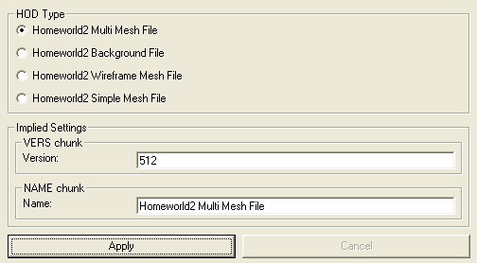
HOD Type: Tells HW2 what kind of HOD this is
- Homeworld2 Multi Mesh File: This is used for Asteroids, Resources, Salvage, Ships, Sub-systems and other “Normal” HODs.
- Homeworld2 Background File: This is used to indicate that this is a background file, though this is never written in the HOD (Version written inside the HOD is different).
- Homeworld2 Wireframe Mesh File: This is used for Wireframe UI meshes.
- Homeworld2 Simple Mesh File: This is used for filled solid UI meshes.
Implied settings: Allows you to edit the information in Version chunk (VERS) and Hod Name chunk (NAME) yourself. This is recommended only if you know what you are doing.
- Textures:
Usually textures are the second thing you should work on. Below is the interface to edit textures in CFHodEd:
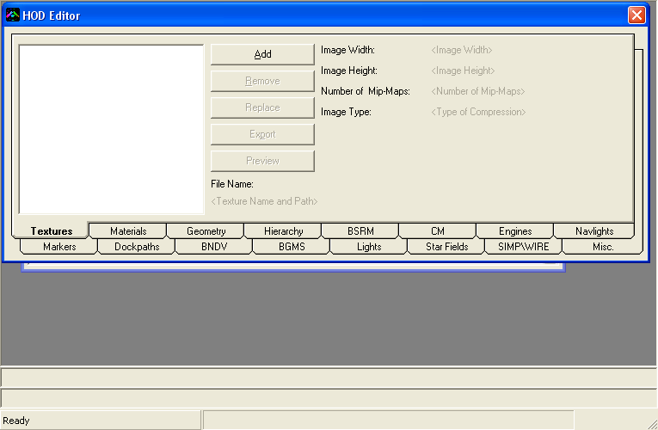
Add: Adds a new texture entry (Note: This is just a dummy texture entry. You must replace it with a proper texture (see below) otherwise you will not be able to save the HOD file).
Remove: Removes the selected texture (entry).
Replace: Replaces the selected texture (entry) with a texture (Only DirectDraw Surface and Truevision Targa only are supported by HW2!)
Export: Exports the selected texture to the path from where CFHodEd is run (Note: Do this only if you can write at the path where the HOD is present)
Preview: Previews the selected texture in a texture preview window. (Note: Do this only if you can write at the "TEMP" directory in Windows)

File Name: Complete path of the texture, when the HOD was written (this is used in HW2 for sharing textures)
Image Width: Width of image.
Image Height: Height of image.
Number of Mip-Maps: Number of MIP MAPS (smaller textures, which are used at greater distances) in the image.
Image Type: Format of image (DXT1, DXT3, DXT5 are DirectDraw Surface, 8888 is Truevision Targa texture)

Preferred format for textures: Direct Draw Surface (DDS)
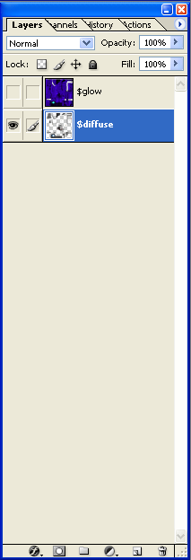
This format is usually always used, since it is much smaller than Truevision Targa. They can be in DXT1, DXT1a, DXT3, or DXT5 format (no other texture formats are supported by HW2). These textures are handled a bit differently as compared to PSD (Photoshop Document). As told in the HW2 Documents, after preparing your textures, and after readying their export versions, textures have “$diffuse” and “$glow” layers. The Hiigaran Interceptor would look like this in Photoshop's Layer window (note that the "Ref" and "Background" layers aren't needed and can be deleted, exactly like Alpha channels):

Naming conventions for textures:
You need to export each and every one of these layers, as “<Original Texture Name>_EXPORT[x].dds”, where x is a number (from 1 to 9), which indicates the layer number, starting from bottom. So in this case, the "$diffuse" layer would be called as "HGN_InterceptorA_EXPORT[1].DDS" and the "$glow" layer would be called as "HGN_InterceptorA_EXPORT[2].DDS". Similarly, for a ship with engines that would glow on and off, "$diffuseOn" would be #1, "$glowOn" would be #2, "$diffuseOff" would be #3, "$glowOff" would be #4, etc. While all this is not really needed, these are healthy practices, which would help avoid errors in the long run.
Incase if you don't have either Photoshop or Paint Shop, you will need a tool, which can write DDS files with alpha (transparency) channels.

Working of Textures with a “ship.st” shader:
Typically, in a "$diffuse" layer,
- Red, Green and blue channel is the base surface texture of ship
- Alpha channel is used for team colours (or base colour). 0 means that it will have 100% effect of team colour, whereas 255 means that team colour will not be applied to that area.

In a "$glow" layer,
- Red channel is unused.
- Green channel indicates how much lit that part of the ship is. Usually, 0-127 is from unlit (depends on lights from other sources) to fully lit (doesn't depend on light from outside), and 128-255 means that the light will seep out into surrounding pixels (will light nearby pixels of the ship texture).
- Blue channel indicates specularity. 0 means that part will not be specular, and 255 means that part is specular.
- Alpha: Stripe colour. Functionality is exactly same as Alpha in a "$diffuse" layer.
- Materials:
Textures, alone are useless. Materials are assigned to objects, and textures are assigned to materials. So for a ship to properly react to light, textures, materials must be properly set. Below is the materials interface in CFHodEd:
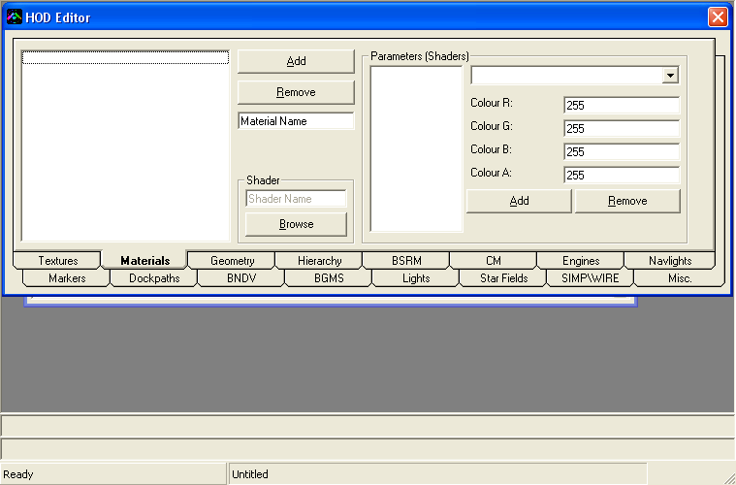
Add: Adds a material
Remove: Removes the selected material
Material Name: Text box, which allows you to change the name of the material. Keep this name identifiable, so that you know which texture is assigned to it.
Shader sub section: Allows you to select a shader that will be used to render the object(s) with this material. Click on the "Browse" button to automatically add parameters to the material. They are needed to properly render objects.
Parameters: Shows the different parameters for the selected material. Usually you don't need to use "Add" and "Remove". Parameters are automatically set when you assign a shader (.st file) to the material. Depending on the type of parameters, you'll either be able to give it a colour, or a texture. As told in the textures section, it is not necessary to always give specific numbers to different layers. You remember that "$diffuse" part of textures needed to be numbered one? Here, in this parameters section, you'll see a "$diffuse" parameters for most type of shaders. There you assign the texture. Have a look at a pre-made ship (from the HW2 Big) to get a good idea of what I mean to say.

Hgn_InterceptorA -> ship -> $diffuse -> Hgn_InterceptorA_Export[2]
(Material) (Shader) (Parameter) (Texture)

Hgn_InterceptorA -> ship -> $glow -> Hgn_InterceptorA_Export[3]
(Material) (Shader) (Parameter) (Texture)

And finally:
Hgn_InterceptorA -> Root_mesh
(Material) (Object, in this case, the mesh)

And this is for each texture used by the object (in this case, "Root_mesh")

This is how, textures, materials and meshes are bound to each other.

Well, the most boring, and possibly difficult part is now over. Read on...
- Geometry
This is what you will see in game. Following is a view of geometry interface of CFHodEd:
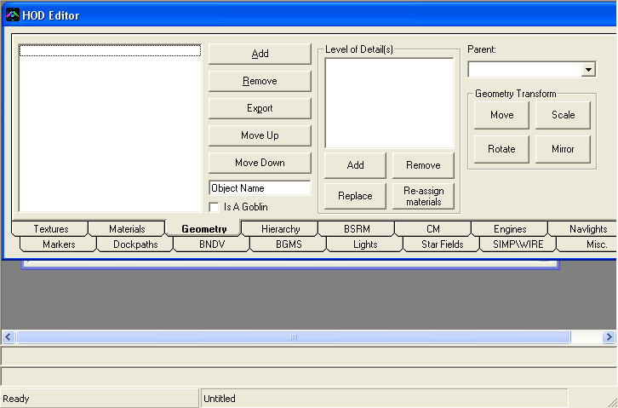
Add: Adds a new mesh
Remove: Removes the selected mesh
Export: Exports the mesh data (vertices, normals, UVs, etc.) to the path from where CFHodEd is run. (Note: Do this only if you can write at the path where the HOD is present)
Move Up: Moves the selected mesh up
Move Down: Moves the selected mesh down.
Object Name: Allows you to edit name of the selected object (usually you should follow the convention “<parent name>_mesh” for normal meshes and “<parent name>_goblins” for Goblins.
Is A Goblin: Marks, whether the selected object is a goblin (detail mesh) or not. Goblins (detail meshes) have a single LoD (Level of detail) only.
Parent: Allows you to select the parent of the selected mesh. Actual positions of meshes are with respect to their parents. This may be needed for animating the ship (ex. moving parts)
LoD Section:
Add: Adds a LoD to the selected mesh
Remove: Removes the selected LoD from the selected mesh.
Replace: Replaces the selected LoD with the mesh you provide.
Re-assign Materials: Allows you to re-assign materials to the selected LoD
Geometry Transform section:
Move: Offsets the selected mesh by the co-ordinates you provide.
Scale: Scales the selected mesh by the values you provide. (Note: This is how many times to scale. So if you provide 2, it will make the selected mesh 2 times it's original size.)
Rotate: Rotates the selected mesh by the values you provide (rotations in degrees)
Mirror: Mirrors the selected mesh in the planes you select.

While importing meshes, you may be asked, whether to weld vertices or not. You should weld vertices for all shapes, except spheres (or other shapes that are symmetrical in 3 Axii).

Also, there is a limitation: No more than 65,535 vertices. This roughly works out to 32,767 faces if you weld vertices, and 21,845 faces if you do not weld vertices.
(Limitation in HOD file format and also in CFHodEd)
- Hierarchy:
Hierarchies are the joints, for different purposes. They are needed for animation and also for NavLights, and Engines, etc. Following is the interface to edit Joints in CFHodEd:
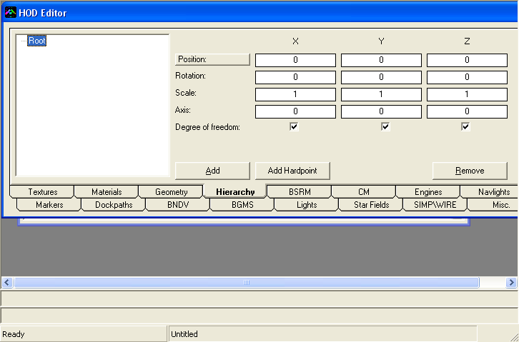
Add: Adds a new joint under the selected parent.
Add Hardpoint: Adds a new hardpoint group (for a specific purpose) under the selected parent. You'll need to specify the base name and type in the screen that follows.
Remove: Removes the selected joint (and all it's children)
Position: Allows you to select the position of the object using a 3d point picker (called as “SIMPLe DRAW X”). You will need to select the objects you want to see, in the “SIMPLe DRAW X” screen)
Key shortcuts when the tree view has the “focus”
  - F2 Rename
  - F3 Rebuild Tree
  - Any other key to refresh the values (Ex. Arrow keys)
- SIMPLe DRAW X:
SIMPLe DRAW X is the interface, which is used to hardpoint joints. Following is a view for “SP_Tanker.hod”:
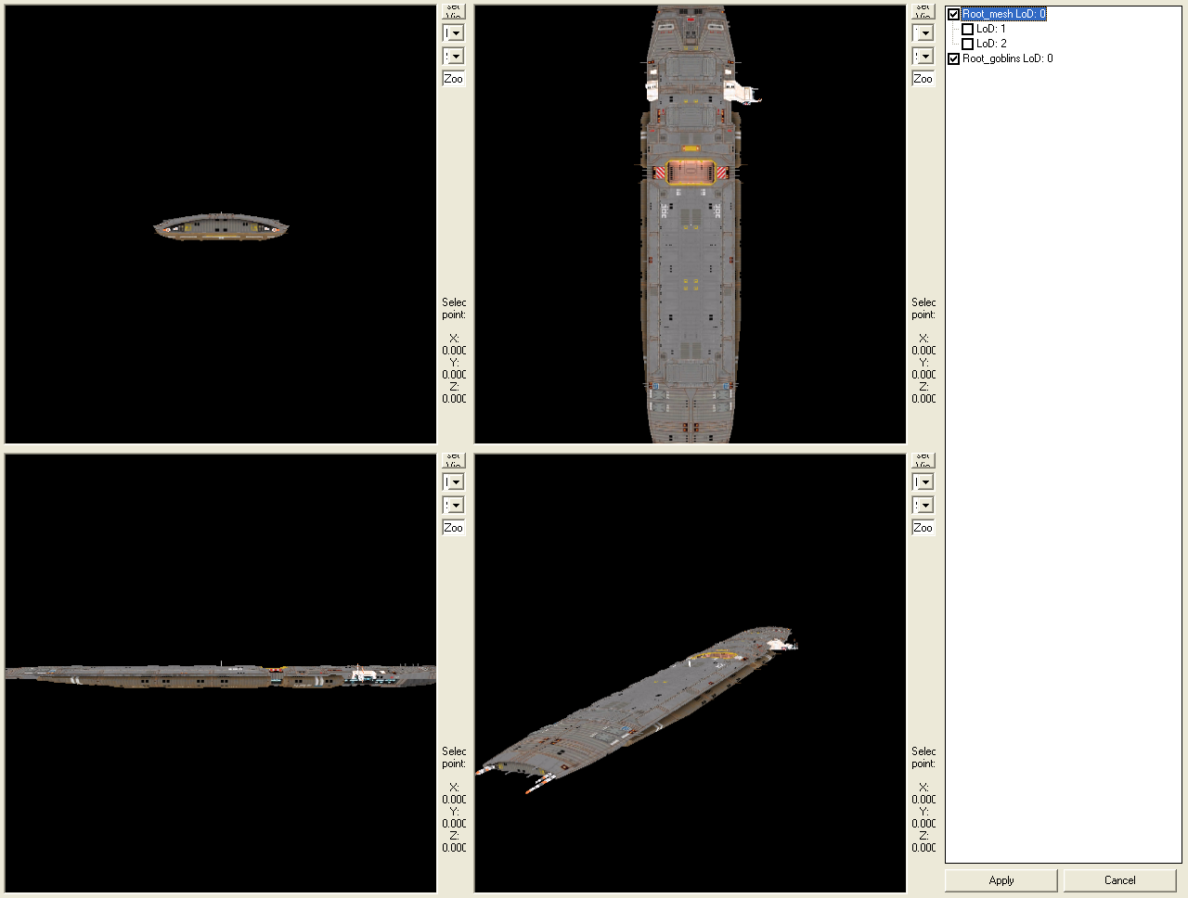
The four windows to the left are the windows for each ‘viewport’. You can pan, zoom, and change the view as needed in each of the viewports.
- The very first button is “Reset View” which will reset view for that viewport only.
- The next combo-box is the way in which you are looking at the object.
- The next combo box is for type of shading – Wireframe or smooth.
- The last text box is for indicating the zoom value – the larger the value the farther you are away from the object.
- The labels indicate the currently “selected” co-ordinates – for information.

The panel towards the right indicates the selected objects. You may want to display lower LoDs of objects; incase you are rendering a large number of polygons.

Apply button saves the selected co-ordinates (and even rotations, where applicable) at the place where you clicked the “Position” button
Cancel button exits without saving the selected co-ordinates (and even rotations, where applicable).

To select a point, you move the “crosshair” (not fully shown in the picture) using keys; since clicking and picking a point will mostly not give the desired result (due to “wrapping” of the view)
In order to move these “crosshair”, the following controls are used:
- Forward: “W”
- Backward: “S”
- Left: “A” or ←
- Right: “D” or →
- Up: “Q” or ↑
- Down: “E” or ↓
- Toggle Rotation Mode: “R”
- Toggle Local move\Global move: “T” (i.e. in ‘Global’ type of move, the crosshair will move forward, but in “Local” type of move, the crosshair will move to it’s forward, when you press the forward button; default is ‘Global’ type of move)

If you turn on Rotation mode, then instead of moving the crosshair, it will be rotated. All rotations displayed in the interface are in radians.

If the crosshair moves too slowly or too fast, the following key combinations may be used to make the crosshair move (or even rotate, where applicable) at a different speed:
- 0.01X “Ctrl” key only
- 0.1X “Shift” and “Alt” keys
- 1X No extra key
- 10X “Shift” key only.
- 100X “Alt” key only.

For optimal performance, you can configure SIMPLe DRAW X’s settings. To modify them, go to Tools->Options. There, select “SIMPLe DRAW X”.
Following are the settings you can change:
  - Filtering:
No filtering: Use this if the SIMPLe DRAW X window lags a lot when rendering. This will completely disable filtering (of textures)
Bilinear filtering: If you want SIMPLe DRAW X to use bilinear filtering only
Anisotropic filtering: If you want SIMPLe DRAW X to use the best quality filtering.
  - Rendering:
Software: If you want SIMPLe DRAW X to use Software ONLY
Hardware: If you want SIMPLe DRAW X to use Hardware if available.
Pure Device: If you want SIMPLe DRAW X to use “Pure Device” when available. This should give a boost in performance.
  - Resolution:
Auto-determine best resolution: If you want SIMPLe DRAW X to use half the resolution of the screen for each viewport. If this is off, minimum resolution is used.
Hi-Resolution: If you want SIMPLe DRAW X to use screen resolution for each viewport (this will surely need beefy system resources, esp. a 3d accelerator).
- BSRM:
BSRM stands for Battle Scar Reference Mesh. That’s right, it is used as a reference for showing scars on objects. HW2 uses this mesh (and it’s normals) to create triangles, on the surface of the object, to show up scars, due to damage caused by weapons. Usually BSRM is exactly same as the respective object, (as BSRMs correspond to objects; i.e. for each object, there is a BSRM and vice versa) since they are used for what will be visible (and noticeable) to the end user. BSRM has many parts, for triangles, or mesh, it’s normals, it’s bounding box (the box in which it is contained, this is abbreviated as BBOX), it’s boundary sphere (this is abbreviated as BSPH) and finally for Spatial sub-division of triangles for better effects (this is abbreviated as SSUB). Following is the interface for modifying BSRMs:
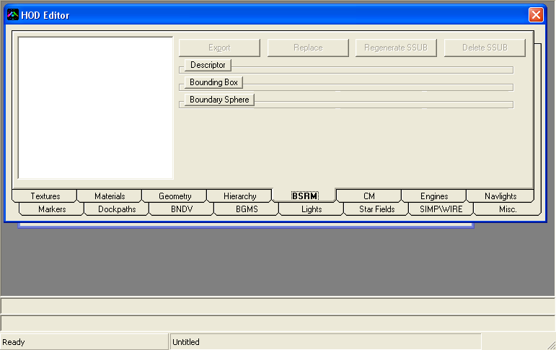
(There is no possibility of adding or removing BSRMs, since they are dependent on the geometry and geometry is dependant on BSRMs)
Export: Exports the selected BSRM mesh data. (Note: Do this only if you can write at the path where the HOD is present)
Replace: Replaces the selected BSRM mesh data with the mesh you provide.
Regenerate SSUB: Regenerates the SSUB data.
Delete SSUB: Deletes the SSUB data (if you don’t want it, or if you manually divided the triangles in your mesh, before importing into CFHodEd)
Descriptor: Opens up the view to show the descriptor of this BSRM.
Name: Name of this object.
Parent Name: Name of this object’s parent.
Level of Detail: Level of detail of this BSRM. 1 is for Non-Goblin and 0 is for Goblin.
Bounding Box: Opens up the view to edit the BBOX of this BSRM.
Minimum Extents: Minimum extents of the BBOX.
Maximum Extents: Maximum extents of the BBOX.
Bounding Sphere: Opens up the view to edit the BSPH of this BSRM.
Center: Center of the BSPH.
Radius: Radius of the BSPH.
- CM:
CM stands for collision mesh. Following is the interface for editing Collision meshes:
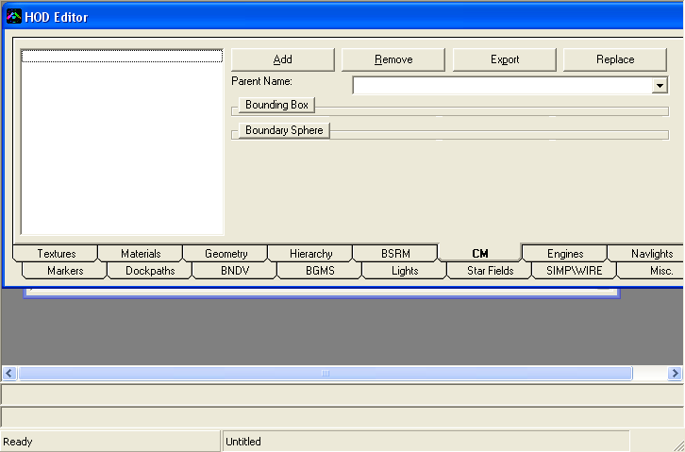
As you can see, there is a lot of similarity between CM and BSRM. But they are used for different purposes. CM is used for collision avoidance, collision detection and for spawning (as compared to BSRM, which is used for scars) weapon effects. CM is based on the basis of joints, not objects (BSRM was based on objects). Therefore, a CM for a ‘Root’ joint will have geometry for all objects parented under ‘Root’ joint. Therefore, CM must not be confused with BSRM; they are for very different purposes.
Add: Adds a new CM entry (Note: You must have only one entry per joint, otherwise, there may be unwanted results, including crashes).
Remove: Removes the selected CM entry (Note: It is possible for a HOD to not to have Collision meshes, but they must have BSRMs).
Parent Name: Name of the joint, to which this CM is parented.
Regenerate SSUB, Delete SSUB, Descriptor, Name and Level of Detail are not used in CM. They are not present.

Rest controls are same as BSRM
- Engines:
Engines define the engines of the ship. Usually, you should copy the information (meshes) from other HODs made by Relic rather than creating one of your own. Though it should not be problematic if you create your own. Engines are divided into three types. The interface for each of them is quite similar. Hence, the interface for “Engine Glow” is explained in detail here:
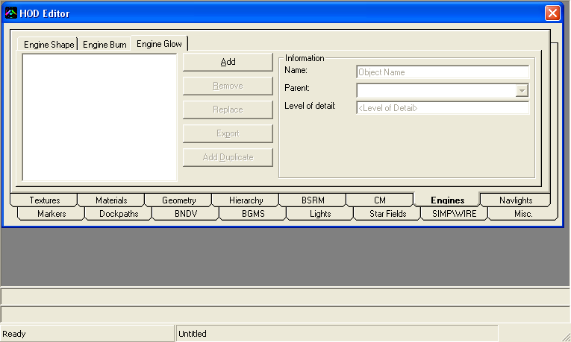
Engine shape is a list of triangles, which define the shape of the engine. This is usually used to determine the place where the engine’s burn sprite will be shown (the one used by fighters and corvettes). They usually point to the direction of the exhaust, or to say, in the backward direction. Engine Burn is a list of vertices, which is used to show the trails of the engine. They are a list of vertices, with later vertices having larger Z value (again, same direction in which the face of engine shapes points at). Finally, engine glow is the “glowing” of the engines (which is used in frigates, destroyers, and still larger ships).
Add: Adds a new object.
Remove: Removes the selected object.
Replace: Replaces the mesh data of the selected object.
Export: Exports the mesh data of the selected object. (Note: Do this only if you can write at the path where the HOD is present)
Add Duplicate: Adds a duplicate of the selected object.
Name: Name of the selected object.
      - For engine shape, name should be “EngineShapeX”, where X is a number.
      - For engine burn, name must be “EngineBurnX”, where X is a number.
      - For engine glow, name must be “EngineGlowX” (if LoD is 0) or “EngineGlowX_LODY” (if LoD is not 0), where X is a number and X is the LoD number.
Parent: Parent of the selected object (Note: This must be “EngineNozzleX” where X is a number; otherwise the game will crash)
Level of Detail: Specifies the Level of Detail of this mesh (Note: This is only for engine glow)

(Note: LoD is only for engine glow; not for engine shape or engine burn)
(Also Note: It is possible for objects to have the same name, and while it is not a pre-requisite that objects should have different parents, but it’s a good idea that objects with same name have different parents.)
- NavLights:
NavLights are created by:
1. First creating a joint (name must be in the form of “NavLightX”, where X is a number or a group of letters); and
2. Then creating a NavLight entry for the NavLight.
NavLights are generally attached to joints; therefore they don’t have parents since the parent of the joint is the parent of the NavLight.
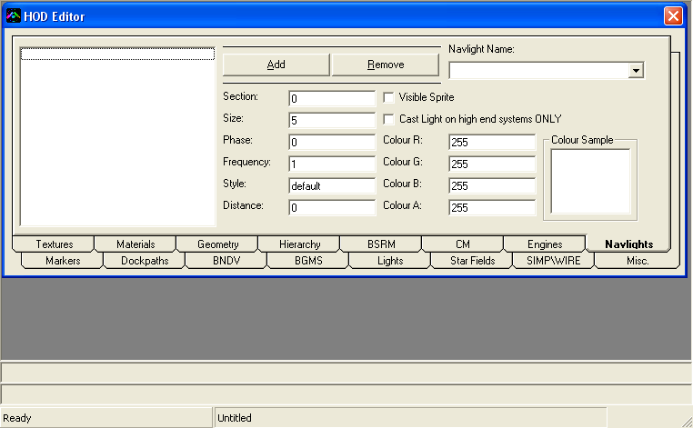
Add: Adds a new NavLight entry.
Remove: Removes the selected NavLight entry.
NavLight Name: The joint to which the selected NavLight is attached.
Section: Unknown.
Size: Size of the NavLight.
Phase: The time taken by the NavLight to turn on\off (?).
Frequency: The frequency of the NavLight for blinking. Smaller the value, longer the time the NavLight turns on\off.
Style: Style of the NavLight.
Distance: Distance from which the light casted by the NavLight is visible.
Colour R G B A: Red, Green, Blue and Alpha colour of the NavLight (0-255).
Visible Sprite: Is the sprite of the NavLight visible? (This could be used for docking bays, which emit light, like the mothership, carrier, etc.)
Cast light on high-end systems ONLY: Self-explanatory.
Colour Sample: How the NavLight will look in game. To mimic Alpha blending, lower the alpha the more the colour would look blackish (this is for preview in CFHodEd only).
- Markers:
Markers are used to define position for effects related to objects. They are also used to define animations, and hence they are called as animation markers. In markers, the “Normal” position is forward direction, which means if you attach a damage effect to a marker, the effect will spray particles in the forward direction (and not upwards). Similarly, a scar will be visible in the forward direction, with XY as it’s plane. Markers have two sections: Header and Animation data.
Following is the section for Header:
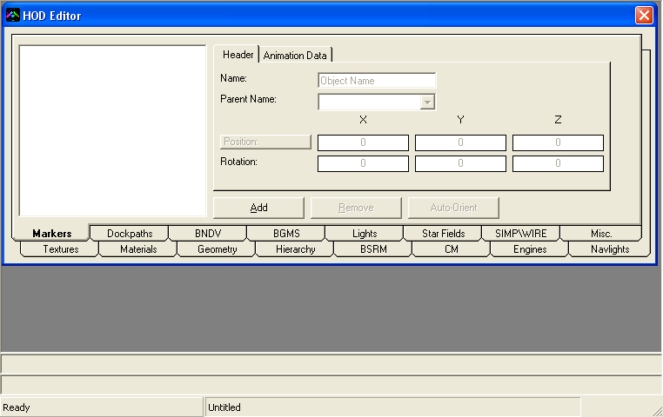
Add: Adds a new marker.
Remove: Removes the selected marker.
Position: Opens up SIMPLe DRAW X to choose position of this marker
Auto-Orient: Automatically orients the selected marker. In this, the backwards of the Z-axis for this marker points towards the origin (which implies that the forward of Z axis points outside). The marker must have a co-ordinate other than (0,0,0) for this to work!

Name: Name of the marker.
Parent Name: Name of the marker’s parent.
X Y Z Position: Position of the marker.
X Y Z Rotation: Rotation of the marker.

Following is the section for Animation (which is not needed if you are not doing anything related to animation):
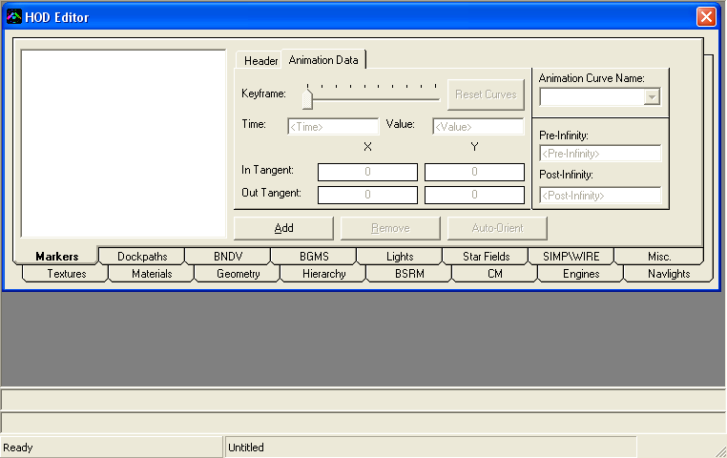
Reset curves: Resets the animation curves (and creates new channels if there are none).
Animation Curve Name: Name of animation curve selected. This is usually “<Name of Marker>_<Channel Name>” Channel Name can be one of follows:
- translateX X co-ordinate
- translateY Y co-ordinate
- translateZ Z co-ordinate
- rotateX X rotation
- rotateY Y rotation
- rotateZ Z rotation
- visibility Visibility (?)
Pre-Infinity: Unknown. Always 0
Post-Infinity: Unknown. Always 0

Keyframe: Current Keyframe.
- Press A to add a Keyframe.
- Press R to remove the selected Keyframe.

Time: Time for the selected Keyframe.
Value: Value for the selected channel (rotations are in radians here)
X Y In Tangent: 0-1 decimal value indicating how much the object’s rotation is affected by its position (?). This may be kept as 1.
X Y Out Tangent: 0-1 decimal value indicating how much the object’s rotation is affected by its position (?). This may be kept as 0.
- Dockpaths:
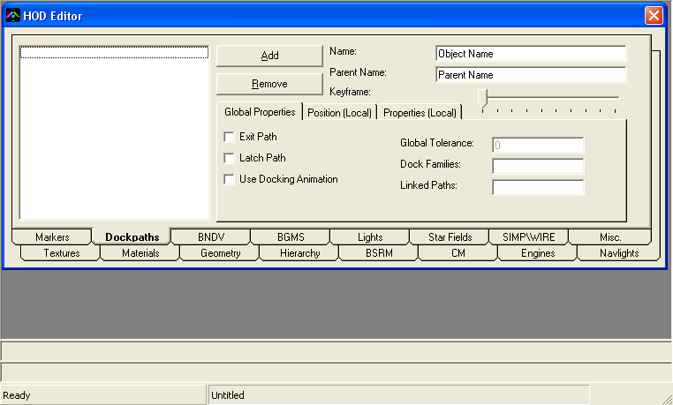
Add: Adds a new dockpath.
Remove: Removes the selected dockpath.
Keyframe Slider: Selects the “Keyframe” or the point of the dockpath, which is being edited (Global Properties are same throughout).

Name: Name of the dockpath (used for identification purposes).
Parent Name: Name of the parent of the dockpath (this is “world”).

Following are the global properties of dockpaths:
Exit Path: Is this an exit path?
Latch Path: Is this a latch path?
Use Docking Animation: Use docking MadStates?
Global Tolerance: Obsolete!
Dock Families: Families of ships that can dock. (Ex. Fighter, Corvette, Frigate, SuperCap, Resource, Utility, etc.; which are defined in “FamilyList.lua”)
Linked Paths: Paths that are linked to this one; they cannot be used unless this is “free” (i.e. when there is no ship on this path)

Following are the local properties of dockpaths (which vary with Keyframe)
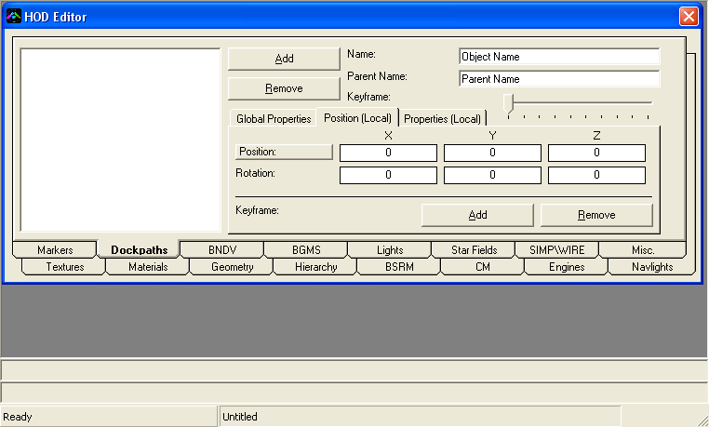
X Y Z Position: Position of dockpath for the selected Keyframe.
X Y Z Rotation: Rotation of dockpath for the selected Keyframe.

Keyframe Add: Adds a new Keyframe to the selected dockpath.
Keyframe Remove: Removes the selected Keyframe.
Position: Opens up “SIMPLe DRAW X” to choose a co-ordinate for the selected Keyframe of the selected dockpath.
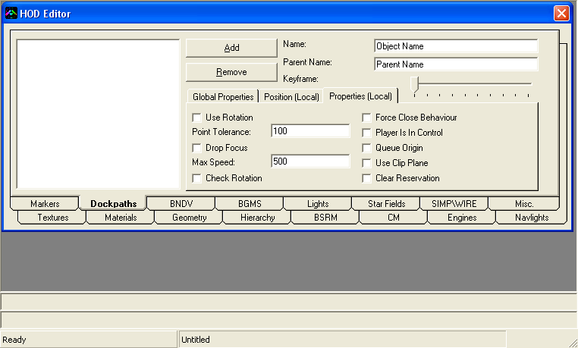
Check rotation: When at this point, ship will check whether it has the required rotation before proceeding ahead.
Clear reservation: When at this point, allow the next ship to exit\launch.
Drop focus: When at this point, drop focus of the camera, if the camera is focused on this ship (not sure if this works).
Force close behavior: Use the exact rotation as on this point until the next point is reached.
Player is in control: Allows the ship to execute orders issued by the player after passing this point.
Queue origin: Is this the point where the ships will queue? (Should be out of the ship’s bounding box; and away from the ship)?
Use clip plane: Use the clip plane so that the ship docking in\out does not intersect the parent ship?
Use rotation: Use given rotations?

Point Tolerance: This is the distance from the point, from which it is assumed that the ship has passed this point.
Max speed: Maximum speed of the ship from this point.

Note: There must be three points, including one queue origin point. Further, the first point must be outside the ships bounding box, otherwise the path won’t work correctly.
- BNDV:
BNDV stands for boundary vertices. They define the boundaries of ships. Right now, only box shaped vertices are used, with two points, one for minimum extents (1st vertex) and other for maximum extents (7th vertex). It is possible to use custom shapes for BNDV, though whether they will work properly or not is a question. So the best thing is to just use “Auto-Calculate” function in CFHodEd for now. Following is the interface to edit BNDV:
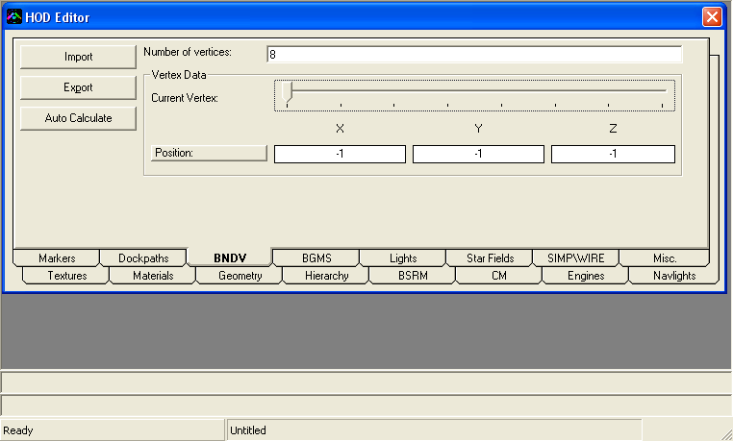
Import: Imports vertices from a Wavefront Object file.
Export: Exports vertices to a Wavefront Object file.
Auto-Calculate: Automatically calculates the extent of the object. You may want to enlarge the BNDV if it has animations (Ex. moving parts).
Position: Opens up “SIMPLe DRAW X” to choose a position for the selected vertex.

Number of vertices: Number of vertices in the BNDV chunk.
Current vertex: The vertex, which is being edited.
X Y Z position: The position of the vertex being edited.
- BGMS:
BGMS stands for background mesh(es). Yes, that’s right, they can be a bunch of different meshes, which contain coloured vertices (and not normals, UV co-ordinates). They contain convex meshes, which are continuous, and have coloured vertices, which are blended to act as a background. Meshes need to divided into parts, because the parts which are not visible, are not rendered, which should increase frame-rate and efficiency. Backgrounds are spherical, but can be of different shapes. They are rendered at the position of the camera, and usually have a radius of 100 units (meters?). BG (background) meshes are contained in “Homeworld2 Background HOD”, i.e. in the HOD attribute window; you must have selected “Homeworld2 Background HOD” for the BG Hod to properly work. In Short: Input for making BG meshes is a mesh, with UV co-ordinates, and it’s corresponding texture (usually of the size 2048x1024, but the aspect ratio MUST be 2:1 for CFHodEd to properly work!). Following is the interface to modify BG meshes:
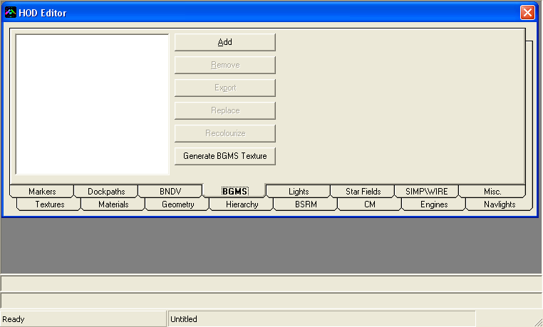
Add: Adds a new BG mesh part.
Remove: Removes the selected BG mesh part.
Export: Exports the selected BG mesh part (vertices only! No colour information is exported).
Replace: Replaces the selected BG mesh with a mesh. The mesh should be a textured mesh, with UV co-ordinates. The UV co-ordinates are used to give colour to vertices, using the texture, which is used by the mesh. Each contrast point must be a vertex, so that the BG Mesh is properly imported.
Re-colourize: Re-colourizes the selected BG mesh with its UV co-ordinates. After saving and re-opening a BG mesh file, all it ‘s UV co-ordinates are lost. In such a situation, “Re-colourizing” the mesh will result in all vertices being given the colour of the very first pixel in the texture (since the UV information is ‘lost’ all vertices will have UV (0,0) when retrieved. Hence, they will get the colour of the first pixel in the texture, and will result in a flat shaded background mesh). Therefore, use this function with caution. Also, images need to be half-toned, i.e. the colour for all pixels must be between 0-127, if it is more than 127 it will emit that colour, and that colour will seep into the surrounding pixels.
Generate BGMS Texture: Spherically unwraps the vertices in different parts of the BGMS chunk and creates a texture. Also, this function allows you to export the mesh that was generated in the process, which contains the UV co-ordinates for the generated texture. This allows you to re-import the mesh-texture into a new BG Hod. (Note: You need to have a 3D Accelerator [Graphic Card] to do this)

Spherical Unwrapping 101:
The function “Generate BGMS Texture “ spherically unwraps the vertices in different parts of the BGMS chunk and creates a gradient between different vertices of the meshes, using DirectX routines. This will allow you to modify pre-made BG meshes as well as create a texture for them. Be advised about the implications of spherical wrapping though. The wrapping in the X-axis of the texture is fixed, but automatic fixation of Y-axis has not been implemented yet. Due to this, the texture generated is not flawless. Although irregular spheres are bound to give problems, given the low mesh density of those parts, colour at those region(s) does not matter (much). Therefore, such regions need to be manually fixed. CFHodEd asks many questions, and you need to properly know the nature of the type mesh to give optimal values. Following are the questions asked by CFHodEd during this process, and what’s done when what input is given is also explained here.
- Attempt to fix circular wrapping?
Sometimes, when working with regular spheres, it becomes difficult to distinguish which quadrant the triangle\vertices belong to. Due to this it becomes hard to assign X co-ordinate to the final texture. To overcome this difficulty, the X co-ordinate assigned to the texture is mean of the rest two vertices. Usually you always use this, especially when the texture mapping is like what is in image (I). After applying this function, the texture map should be like image (II) [Note that this is just what should be, actual results may vary].

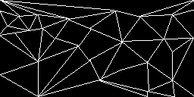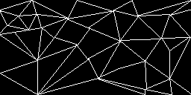
Image (I) Image (II)
- Enter size multiplier for generated image:
Default size for the BG texture is 2048x1024 pixels. If you need a larger\smaller image, you may use this. Note that the largest texture size is 4096x4096, therefore, the largest texture exported is 4096x2048, which means that Size Multiplier is between 0 and 2 (2 is included)
- Enable Alpha-blending?
Alpha blending, so that images are blended in the alpha channel. Note that the image will get blended against black, so this may not be needed.
- Enable Anti-Aliasing?
Anti-aliasing, if you graphics card supports it.
- Engine Depth (Z) test?
Depth test, you should enable this, always, since some triangles are purposely pushed backwards.
- Double-tone image?
Images are half-toned when creating a background image. Usually for a texture, if a pixel has any colour more than 127, it would emit that colour. Hence, all colours are kept between 0-127. You may want to double tone the output image to make sure it looks proper.
- Create Additional faces to account for Circular wrapping?
In case of irregular spheres, some faces are midway between the first and fourth quadrant. Due to this, the center, if it lies in first quadrant, the triangle is rendered on the left, and if the center lies in the fourth quadrant, the triangle is rendered in the right, and the image is left incomplete with missing parts towards the left\right. To overcome this difficulty, triangles towards the left and right are duplicated towards each side. Although this takes more time and decreases efficiency, this produces good results. Most type of sphere meshes are properly unwrapped with this setting on. Try unwrapping meshes with this on and off to see the difference.
- Duplicate faces towards the top or bottom sides?
Sometimes, when faces towards the sides are duplicated, they may also have a vertex, which is towards the top or bottom. If such a triangle is duplicated, it may overlap other triangles, due to which the gradient of the texture, i.e. the output texture gets spoilt. Hence, usually you should keep this off, but if you find missing parts towards the sides, try this with on.
- Lower threshold to create faces from the LEFT side (0-1)?
All the faces, which fall from zero to the given value, are duplicated. For example, if you give a value of 0.125, all triangles with UV 0-0.125 are duplicated and put in the right side.
- Upper threshold to create faces from the RIGHT side (0-1)?
All the faces, which fall from the given value to one, are duplicated. For example, if you give a value of 0.875, all triangles with UV 0.875-1 are duplicated and put in the left side.

- Triangle Cull-Mode:
Lets you select the triangle cull mode. CCW (Counter-Clockwise) is the default, but CW (Clockwise) allows you to see which triangles are not being rendered in CCW mode, and “No Triangle Culling” allows you to see all triangles. Select the texture with CCW or no culling, whichever looks better to you.

- Save Generated meshes (with UV co-ordinates)
Allows you to save the meshes, which were generated when the texture was being created. These meshes can use the generated texture to mimic the background almost exactly as it was in HW2.
- Lights:
Background lights are needed for lighting. They are contained in HODs independent of the background meshes, and these HODs are multi-meshes i.e. you must have selected “Homeworld2 Multi-Mesh” in the HOD attributes window.
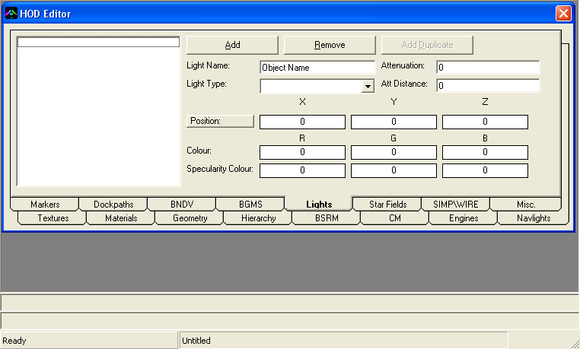
Add: Adds a new light.
Remove: Removes the selected light.
Add Duplicate: Duplicates the selected light.
Position: Opens up SIMPLe DRAW X to choose the co-ordinates of the light.

Light Name: Name of the light.
Light Type: Type of light.

X Y Z Position: Position of the light.
R G B colour: Colour of the light.
R G B specularity: Unknown. It is observed to be half of the colour.

Attenuation: Unknown usage.
Attenuation Distance: Unknown usage.
- Star fields:
Star fields are included in the background HOD, which has background meshes. Star-fields are of two types:
    - STRF (Star Fields)
These are point stars, with colour, no alpha no texture. Groups are on basis of position of stars, in different parts, quadrants, etc.
    - BGSG (Background Stars)
These are stars with a texture (star image). They have alpha, and one group has a specific texture. Groups are on basis of texture.
Since they are extremely similar, the interface to edit them is the same.

Below is the interface to edit star-fields:
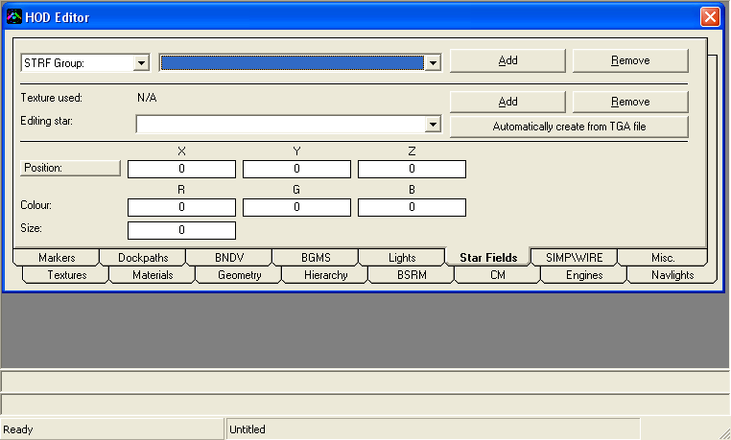
Group being edited: STRF Group or BGSG Group: Select the type of object you want to edit.
Star-field object number: Select the object number you want to edit.
Add: Add a new object.
Remove: Remove the selected object.

Texture Used: Texture used by the object group (only for BGSG type of stars).
Add Star: Adds a new star in the selected object.
Remove Star: Removes the selected star from the selected object.
Editing star: Star being edited
Automatically create from TGA: Automatically create stars in the selected type from a Truevision Targa (TGA) texture

Position: Opens up SIMPLe DRAW X to choose a position for this star.
X Y Z Position: Position of this star.
R G B A Colour: Colour of this star.
Size: Size of this star.
- SIMP\WIRE:
SIMP stands for Simple Mesh, and WIRE stands for Wireframe mesh. While both are same, they are read differently. This must be indicated properly in the HOD Attributes section. SIMP\WIRE is usually used in the UI. It is observed that Wireframe HODs have a single mesh group with no name. While this isn’t a hard and fast rule, you should stick to the conventions. Following is the interface to edit SIMP\WIRE meshes:
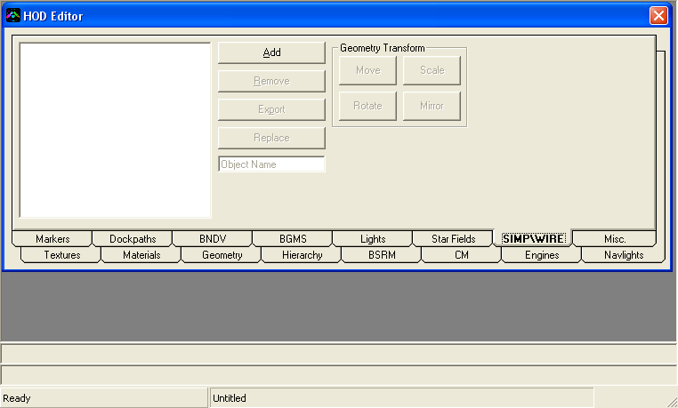
As you can see, all of the UI here is same as for “Geometry” section. Therefore, the controls in “SIMP\WIRE” section are not discussed here, as they have the same function for this data type.
Note: In case of Wireframe meshes, while importing, if they have triangles\polygons, their edges are imported (a bit inefficiently). If they don’t have triangles, then they are imported EXACTLY as they are (vertices) into the mesh (in the HOD). If this is the case (which is for all Wireframe meshes exported from CFHodEd), then the mesh should have SAME number of vertices\normals as they are used in these types of meshes. If there aren’t equal numbers of vertices\normals, then extra vertices don’t get a normal, which is NOT a good thing!

- Misc.:
Misc. section contains all the miscellaneous information stored in the HOD like warnings, errors occurred, name of the creator\owner, etc. (former two are esp. related to export procedure from Maya. The latter, can be edited if you are creating a new HOD. Following is the interface:
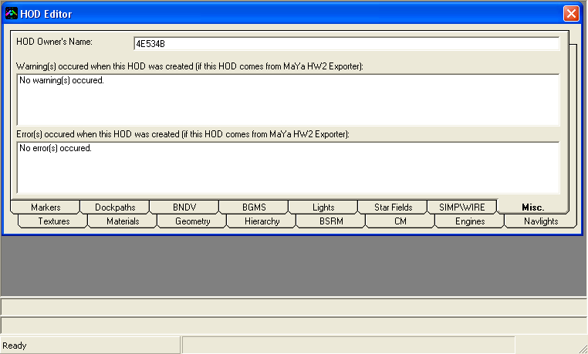
Owner’s Name: Self-explanatory.

(Following are applicable only for HODs exported from Maya)
Warnings: Lists all the warnings, if any, during export from Maya.
Errors: Lists all the errors, if any, during export from Maya.
3. Error Messages:
- General:
“No Geometry in HOD (!)”
There is no valid geometry for the type of HOD selected. You need to make sure that you have relevant geometry. While this is not required, in some cases it may result crashes in HW2. If you are making a UI mesh, you must have at least one SIMP\WIRE chunk, for a BG HOD, make sure you have one BG mesh (in the BGMS section) and for ‘normal’ HODs, you’ll need at least one geometry object (in the geometry section).

“Battle Scar Reference Mesh\Multi-Mesh or Goblin count mismatch (X and Y respectively). Please correct.”
“Multi-Mesh\Goblin Name and Battle Scar Reference name mismatch for object number X (<object name 1> & <object name 2> respectively). Please correct.”
[X, Y are numbers; <object name 1>, <object name 2> are names of the concerned objects]
Tough one. CFHodEd maintains geometry and BSRMs, so the cause of these errors can only be missing BSRM chunks, when the file was opened.

“Battle Scar Reference mesh number X doesn't have vertex\face data! Please Correct.” [X is a number]
BSRMs need to have some data inside them, since they are used for making scars on ships. You need to import the same LoD0 mesh for the respective object into the concerned BSRM to fix this error.

- Textures:
“This file has no '[x]' tag. Please make sure that you give them a '[x]' tag” [X is a number]
Textures need to have a numeric tag in their name, within square brackets. Put a number in there! (Ref: Naming conventions for textures)

“Unknown texture format: <4 words>” [<4 words> are words denoting the format of texture]
Textures either need to be in a format of:
    - Direct Draw Surface
      - DXT1 (No Alpha)
      - DXT1a (1-bit Alpha)
      - DXT3 (Explicit Alpha)
      - DXT5 (Interpolated Alpha)

    - Truevision Targa (32-bit uncompressed TGA files only!)

Any other formats will fail to work. (Ref: Preferred format for textures)

“Couldn't extract texture to temporary location for preview!”
Make sure that:
- You temporary folder environment variable exists. (“ %TEMP%” is the variable referenced by CFHodEd)
- It is present
- You have enough disk space
- CFHodEd has permission to write.

“Invalid texture detected (index: X). Please remove” [X is a number]
It may be because you didn’t replace that texture entry with a proper texture.

- Geometry:
“Geometry Object number X (name: <object name>) is empty. Please Remove.”
“Geometry Object number X (name: <object name>) LoD Y has no parts! Please ensure that geometry is present.”
“Geometry Object number X (name: <object name>) LoD Y part Z has no vertices\faces! Please ensure that Vertices\Faces are present.”
[X, Y, Z are numbers, and <object name> is name of the concerned object]
Make sure you have geometry, mesh, vertex and face data in the concerned geometry object.

- Hierarchy:
“Joint #X and Joint #Y have same names! Please fix.” [X, Y are numbers]
Make sure the two joints don’t have the same name (since it will cause a naming conflict).

- CM:
“Collision Mesh number X (called as <object name>) has no vertices\faces!” [X is a number, and <object name> is name of the concerned object]
Make sure the concerned CM has mesh data. Otherwise, remove it.

- BGMS:
“BGMS part #X is empty. Please fix...”
“BGMS part #X has no vertices. Please fix...”
“BGMS part #X has no faces. Please fix...”
[X is a number]
Make sure the concerned part has mesh information. Otherwise, remove it. But you will need at least one mesh with mesh data, if you don’t want a black Background.

- SIMP\WIRE:
“SIMP\WIRE mesh #X has no vertices. Please correct.”
“SIMP\WIRE mesh #X has no faces. Please correct.”
[X is a number]
Make sure the concerned mesh part has mesh data. Otherwise, remove it. But you will need at least one mesh with mesh data to use in the UI.

4. Theory:
e. HOD Scripting
CFHodEd has a feature, which can be pretty useful at times, and can also automate (to some extent) boring tasks. To accomplish this, scripting has been implemented in CFHodEd. You can import, what is called, HOD Scripts, in to automatically create\convert all the information in them into HOD format. These scripts are called HSC (Hod SCripts). You import these scripts using File->Import->HOD Script (HSC), and CFHodEd parses them. You can use this feature for multiple purposes like:
- Automatically importing a large group of meshes
- Automatically adding a group of joints, i.e. a hierarchy of joints, which can be used to add joints with same base name, and same hierarchy (templates of joints, not in-built in CFHodEd)
- Automatically duplicate dockpaths with same information, which can be changed later by you (this would be useful in symmetrical ships)
- And so on… (The possibilities depend on usage)

HOD scripts are essentially like C++ source code. They follow same format as in C++
  - Comments start from “//”
  - You may keep any amount of spaces\tabs for your ease of view
  - Paths are relative to the path of the script
  - Arguments for functions are in brackets
  - Anything after a bracket close [“)”] is ignored
  - You may optionally add a “;” to denote end of sentence

Following are the functions that can be used and their usage:

Scale
To set the scale of objects that are imported AFTER call to this:
HOD__ImportScale(<X Scale>, <Y Scale>, <Z Scale>);
Ex. HOD__ImportScale(2, 2, 2);

To set the scale of all objects that are present TILL now:
HOD__CompleteScale(<X Scale>, <Y Scale>, <Z Scale>);
Ex. HOD__CompleteScale(2, 2, 2);

Textures
To add a texture (process is same for both DDS and TGA; and both need tags):
LMIP_Add(<relative path to the texture>);
Ex. LMIP_Add("\Texture[1].dds");
LMIP_Add("\Texture[1].tga");

Materials
To add a material:
STAT_Add(<name>, <shader name>, <number of layers (parameters));
Ex. STAT_Add("hw2Shader", "ship", 2);
STAT_Add("hw2Shader1", "background", 2);

To set properties of a parameter:
STAT_SetParamter(<material number, starting from 1>, <parameter number, starting from 1>, <type of parameter (4 = colour; 5 = texture)>, <colour R; value from 0-1; ignored when type is not 4>, <colour G; value from 0-1; ignored when type is not 4>, <colour B; value from 0-1; ignored when type is not 4>, <colour A; value from 0-1; ignored when type is not 4>, <index to texture, from 1; ignored when type is not 5>, <name of this parameter, like "$diffuse", "$glow", etc; ignored when type is not 5>);
Ex. STAT_SetParamter(1, 1, 5, 1, 1, 1, 1, 1, "$diffuse");
STAT_SetParamter(1, 2, 5, 2, 1, 1, 1, 1, "$glow");
STAT_SetParamter(1, 1, 4, 1, 1, 1, 1, 0, "");
STAT_SetParamter(1, 2, 5, 1, 1, 1, 1, -1, "");

Geometry
To add a object:
MULT_Add(<name>, <is a goblin>, <parent Name>, <number of LoDs; 4 will give LoDs 0-3, 3 will give LoDs 0-2, 2 will give LoD 0 and LoD 1, etc; ignored when object is a goblin>);
Ex. MULT_Add("Root_mesh", "Root", 0, 4);
MULT_Add("Root_goblins", "Root", 1, 1);

To replace a LoD with proper geometry:
MULT_SetLoD(<geometry number, starting from 1>, <LoD number, starting from 0>, <relative path to OBJ file>);
Ex, MULT_SetLoD(1, 0, "\Root_mesh_LOD0.obj");
MULT_SetLoD(1, 0, "\Root_mesh_LOD0.obj");
MULT_SetLoD(1, 1, "\Root_mesh_LOD1.obj");
MULT_SetLoD(1, 2, "\Root_mesh_LOD2.obj");
MULT_SetLoD(1, 3, "\Root_mesh_LOD3.obj");
MULT_SetLoD(2, 0, "\Root_mesh_GOBG.obj");

Hardpoints
To add a joint\hardpoint:
[Note: Rotations\Axis are\is in degrees]
HIER_Add(<name>, <parent name>, <X position>, <Y position>, <Z position>, <X rotation>, <Y rotation>, <Z rotation>, <X scale>, <Y scale>, <Z scale>, <X Axis>, <Y Axis>, <Z Axis>, <Free to rotate in X Axis? >, <Free to rotate in Y Axis? >, <Free to rotate in Z Axis? >);
Ex. HIER_Add("Hardpoint1", "Root", 10.5, -15, 300, 0, 0, 0, 1, 1, 1, 0, 0, 0, 1, 1, 1);

Battle Scar Reference Meshes
[Automatically handled by geometry import]

Collision Meshes
To add a collision mesh:
COLD_Add(<parent name, pointing to a joint>, <path to OBJ containing mesh>);
Ex. COLD_Add("Root", "\Root_mesh_COLD.obj");

Engine Trail Shape
To add a ETSH (Engine Trail SHape):
ETSH_Add(<name>, <parent name>, <path to a OBJ>);
Ex. ETSH_Add("EngineShape1", "EngineNozzle1", "\EngineShape1_ETSH.obj");

Engine Burn
To add a BURN (Engine BURN):
BURN_Add(<name>, <parent name>, <path to a OBJ>);
Ex. BURN_Add("EngineBurn1", "EngineNozzle1", "\EngineShape1_BURN.obj");

Engine Glow
To add a GLOW (Engine GLOW):
GLOW_Add(<name>, <parent name>, <level of detail>, <path to OBJ>);
Ex. GLOW_Add("EngineGlow1", "EngineNozzle1", 0, "\EngineGlow1_GLOW0.obj");
GLOW_Add("EngineGlow1_LOD1", "EngineNozzle1", 1, "\EngineGlow1_GLOW1.obj");

NavLights
To Add a NAV Light:
[Note: Colour is a decimal value; from 0.0 to 1.0]
NAVL_Add(<joint to which NavLight is attached>, <section>, <size>, <phase>, <frequency>, <style>, <colour (Red)>, <colour (Green)>, <colour (Blue)>, <colour (Alpha)>, <distance>, <Is Visible? >, <Cast Light On High End Systems only? >);
Ex. NAVL_Add("NavLight1", 0, 5, 0.5, 2, "default", 1, 1, 0, 1, 600, 1, 1);

Markers
To add a marker:
[Note: Rotations are in radians]
MRKR_Add(<name>, <parent Name>, <start Keyframe Time>, <end Keyframe Time>, <X Position>, <Y Position>, <Z Position>, <X Rotation>, <Y Rotation>, <Z Rotation>, <num. animation chunks>);
Ex. MRKR_Add("marker1", "Root", 0, 0, 15, 65, -150, 0, 45, 0, 0);
MRKR_Add("marker1", "Root", 0, 1, 15, 65, -150, 0, 45, 0, 2);

To set an animation chunk to a marker:
ANIM_Set(<marker number>, <animation chunk number>, <curve Name>, <num. Key Frames>, <pre Infinity>, <post Infinity>);
Ex. ANIM_Set(1, 1, "marker1_translateX", 2, 0, 0);

To set a keyframe for a animation chunk in a maker:
[Note: Rotations are in radians (i.e. when the "channel" is "*_rotate?"]
[Also, Scale is not applied here]
KEYF_Set(<marker number>, <animation chunk number>, <keyframe number>, <time>, <value>, <in-Tangent X>, <in-Tangent Y>, <out-Tangent X>, <out-Tangent Y>);
Ex. KEYF_Set(1, 1, 0, 0, 1, 0, 1, 0);

Dockpaths
To add a dockpath:
DOCK_Add(<dock path Name>, <dock path Parent name, this is "world">, <is this exit>, <is this latch>, <families that can dock>, <use animation>, <names of lined paths>, <number of keyframes, MUST BE MORE THAN 2! >);
Ex. DOCK_Add("path1", "world", 1, 1, "Utility", 0, "", 2);

To set Keyframe data:
DOCK_SetKeyframe(<dockpath number, starting from ONE>, <Keyframe number, starting from ONE>, <X position>, <Y position>, <Z position>, <X rotation>, <Y rotation>, <Z rotation>, <Use Rotation>, <Point Tolerance>, <Drop Focus>, <Max Speed>, <Check Rotation>, <Force Close Behavior>, <Player Is In Control>, <Queue Origin>, <Use Clip-Plane>, <Clear Reservation>);
Ex. DOCK_SetKeyframe(1, 1, 0, 0, 0, 0, 0, 0, 0, 5, 0, 500, 0, 0, 0, 0, 0, 0);
DOCK_SetKeyframe(1, 2, 0, 0, 10, 0, 0, 0, 0, 100, 0, 500, 0, 0, 0, 0, 0, 1);

Boundary Vertices
To set the number of BNDVs:
BNDV_SetNumVertices(<num. Vertices);
Ex. BNDV_SetNumVertices(8);

To set a BNDV vertex:
BNDV_SetVertex(<vertex number>, <X position>, <Y Position>, <Z Position>);
Ex. BNDV_SetVertex(1, -50, -25, -100);

To auto-calculate BNDV:
BNDV_AutoCalc(<BNDV enlargement factor; this is applied EVEN after the user chooses to slightly enlarge BNDV>);
Ex, BNDV_AutoCalc(1);

Background Meshes
To add a background mesh:
BGMS_Add(<relative path to the mesh>, <relative path to the texture, which is to be used for colourizing the mesh>)
Ex. BGMS_Add("\Part1.obj", "\Texture.tga");

Lights
To add a light:
[Note: Colour\Specularity is a decimal number, with value 0.0 to 1.0]
LITE_Add(<name>, <type: Ambient Light = 0; Area Light = 1; Directional Light = 2; Point Light = 3; Spot Light = 4; Volume Light = 5>, <X position>, <Y position>, <Z position>, <R colour>, <G colour>, <B colour>, <R specularity>, <G specularity>, <B specularity>, <attenuation>, <attenuation distance>);
Ex. LITE_Add("Light0", 0, 0, 100, 0, 1, 1 1,0.5, 0.5, 0.5, 0, 0);

Simple\Wire-frame Meshes
To add a simple\Wireframe mesh:
SIMP_Add(<name>, <path to the mesh>);
Ex, SIMP_Add("Box", "\Box_SIMP.obj");

5. Miscellaneous information:
Incase of any feature requests, questions, bugs, errors, either post at the Relic forums (Tanis Shipyards), or e-mail me at 4E534B@gmail.com

You may use source code of CFHodEd to derive Homeworld2 HOD editing programs, and mentioning my name is not necessary.
You may use source code of CFHodEd to derive (non-commercial) programs from it, but you must mention the name of the author(s).
You may use SIMPLe DRAW or SIMPLe DRAW X for non-commercial purposes, but you must mention that it was made by me, 4E534B; and that it uses DirectX 8.

CFHodEd is provided “as is”, without any warranty, of any kind, whether express or implied, or even fitness for any\particular purpose. In no way the author(s) of this program will be responsible for any kind of indirect, incidental, consequential damage of any kind.

